ABHISHEK SHARMA

500067644

R171218005

**CLOUD COMPUTING**

**1**

**Introduction:**

* **Cloud Simulator**:Cloud simulatoris software that allows you to simulate the physical and logical structure of data centers in the cloud, which contains thousands of physical machines and hundreds of thousands of virtual machines in an ordinary computer

**Cloud Simulation tools:**

* CloudSim
* CloudAnalyst
* GreenCloud
* iCanCloud
* GroudSim
* **Cloud Provider:** A cloud service provider is a third-party company offering a cloud-based platform, infrastructure, application, or storage services. companies typically have to pay only for the amount of cloud services they use, as business demands require.

**Types of Cloud Providers:**

1. **Open Source Cloud Providers: -**

* Open Stack
* CloudStack
* Eucalyptus

1. **Commercial Cloud Providers: -**

* AWS
* Microsoft Azure
* Google Cloud

**Simulation tools**

**1) Cloud Sim: -**

* Models Cloud Computing Environments , Data Centres ,VM ,application
* Written in Java
* Allows to Examine Application Services
* Allows to examine application Services
* Allows Dynamic addition/removal of Resources
* Developed at clouds Lab at University of Melbourne

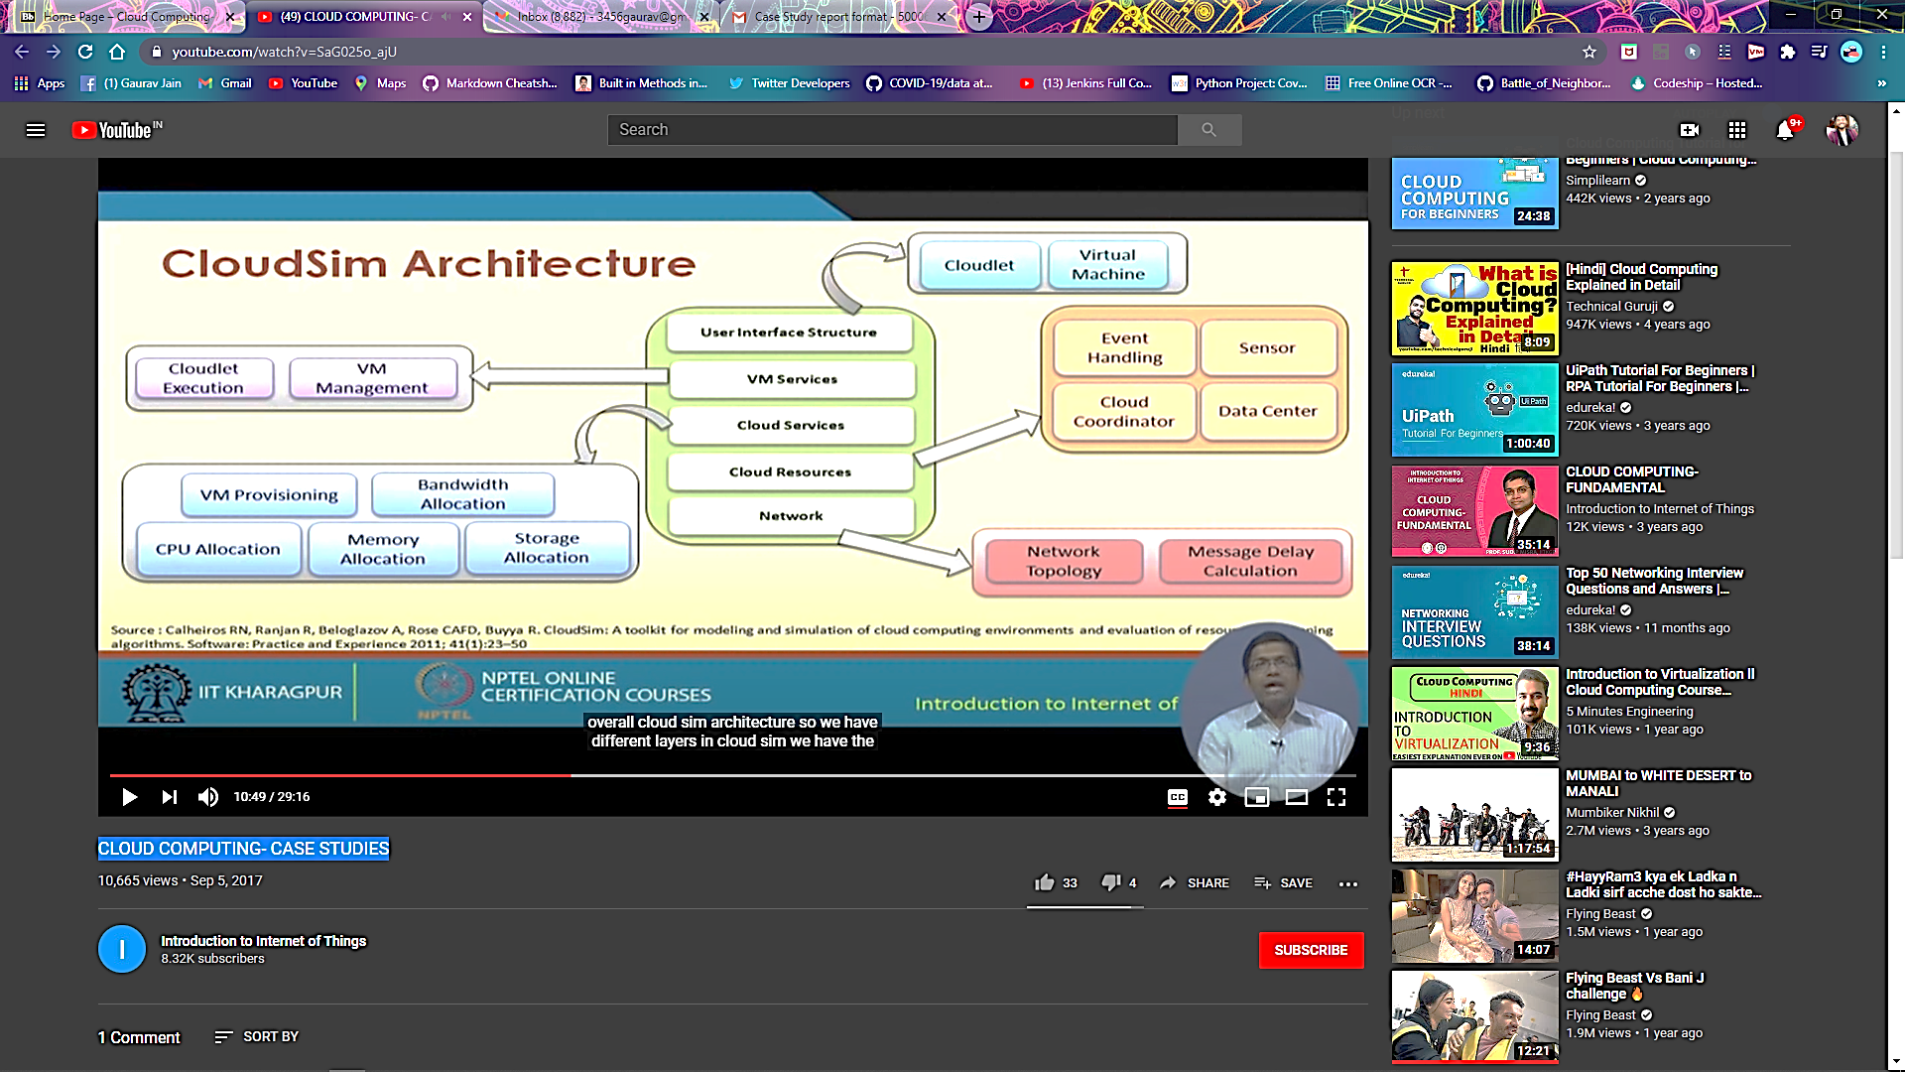

**Advantages of CloudSim:**

* Time Effectivness
* Flexibility and Applicability

**Architecture of CloudSim:**

1) Topmost Layer (Machine and application Specification)

* Users,Physical Machines,Virtual Machines,Application and Services,Scheduling Policies

2) Middle Layer

* Provides Cloud Environment
* Enables Modeling and Simulation

3) Bottom Layer

* Event Scheduling
* Entity Creation
* Interaction between Components
* Clock Management

**2) CloudAnalyst :**

* Simulation tool designed based on CloudSim Provides GUI
* Supports geographically distributed large-scale-cloud Applications
* Study Behaviour of such Applications Under Various deployment Configurations

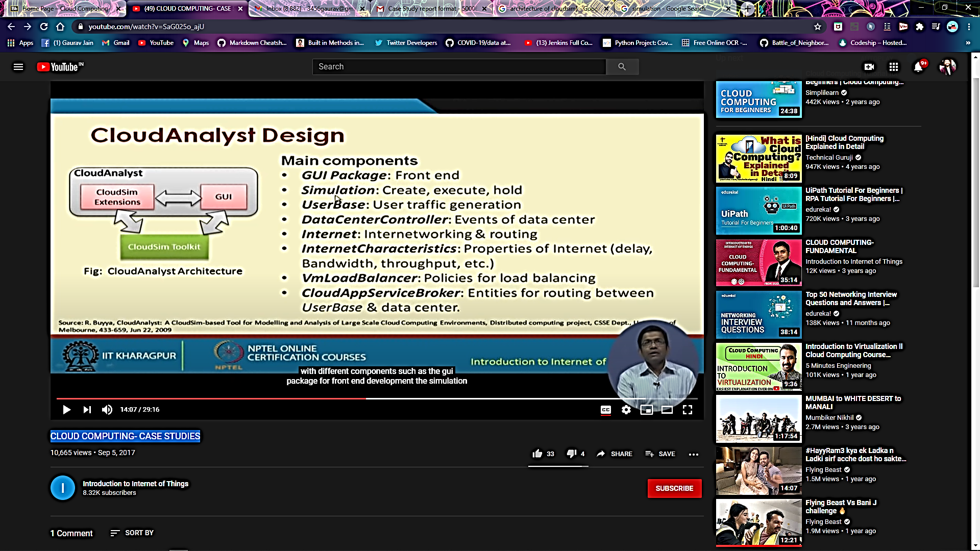

**Features of CloudAnalyst**

* Easy to use
* High level Configuration
* Graphical Output
* Easy to Extend

**Main Components of CloudAnalyst :**

* GUI
* Simulations
* Userbase
* DataCenter Controller
* VM Load Balancer
* cloudApp Service Broker

**3) Green Cloud:**

**Why:**

* The computing capacity has increased the cost and operational expenses of dataCenters
* Energy Consumption by Data Centers is the Major factor driving Operational Expense

**What:**

* Operational Cost is the Energy utilized by Computing and Communication units within a data Center

**How:**

* Green Cloud monitors the energy consumption of switches ,servers etc
* Developed as an Extension of a packet-level simulator NS2

**Features:**

* User Friendly GUI
* Open Source
* Monitors Energy Consumption
* Supports Simulation of Cloud Network Components

1. **Open Stack**

* Collection of open Source Technologies
* Managed by open stack Foundation
* Supports Vastly scalable Cloud System
* Considered as Iaas
* Ease of use
* Developed software applications can be used by end user

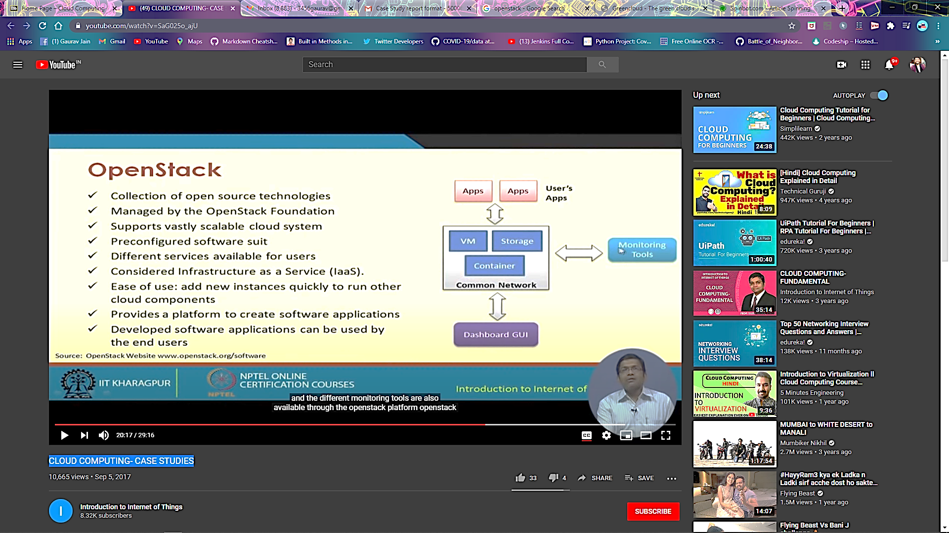

**Components of OpenStack**

* Compute
* Networking
* Block Storage
* DNS
* Key Manager

**Features of openStack:**

* Allows Users to Create and deploy virtual Machines
* Allows Set up Cloud Management environment
* Supports easy horizontal Scaling

1. **Microsoft Azure:**

* Supports Iaas and Paas
* Supports extensive set of Services to quickly create ,deploy and manage applications
* Many programming languages and frame works are Supported
* Available across Microsoft-managed datacenters

**Services:**

* Compute
* Mobile Services
* Data Management
* Messaging
* Media Services
* Content Delivery Network

**Azure as Paas**

* Platform is provided to clients to develop and deploy software
* Clients focus on Application deployment rather than worry about hardware and infrastructure
* Low cost
* Ease to move on to new tools

**Azure as Iaas**

* Offers Total Control of the OS and application Stack
* Features to access ,manage and monitor the data Centers
* Facility for loading of Custom Configurations

1. **Amazon Elastic Compute Cloud(EC2)**

* A Web Service for User’s to launch and Manage Server instances in Amazons data Center
* Provides Various API’S tools and Utilities
* Facilitate dynamic computation scaling in AWS Cloud
* Supports pay-per-bill

**Features of Amazon EC2**

* Supports all OS
* Storage

1. Temporary:Local ‘Instance Storage’
2. EBS
3. S3

* Automated Scaling
* Different availability zones in data centers increases fault-tolerance
* Firewall Rules/Security Groups
* Elastic I/P address
* Amazon CloudWatch
* Enhanced Security
* Virtual Private Clouds

**2**

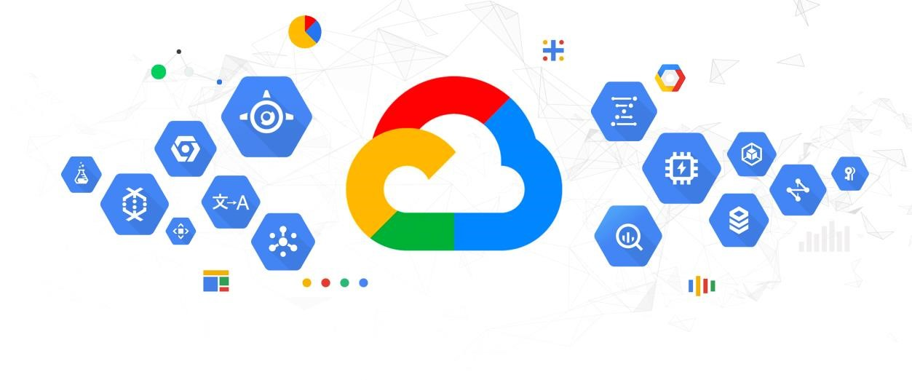

**Introduction**

With respect to specific execution for business improvement, the advancement in a remarkable interest is, Cloud Computing. We think about its ability to send and manage other in-house shows which are solely subject for quality assessment.

Circulated registering progresses are offered by many driving associations like AWS, Microsoft, Tableau and Google with different designing and use. The customers can go for any of them as per their essentials and internal business structures and edges. We have learned about google cloud stage!

**What is Google Cloud Computing?**

If you accept that Google is just a web crawler with messages, accounts and pictures amassing, and scarcely any various functionalities, this article will change your acknowledgment. Without a doubt! Google moreover is a totally fledged conveyed figuring body with absolutely dazzling features. Its appropriated processing stage gives a splendid base creation it easy to amass an extent of ventures from direct destinations to outstandingly complex applications.

**Components of Google Cloud Computing Platform**

There are five huge segments recorded in the Google Cloud Computing Platform. They are sent for unprecedented tasks.

* **Google Compute Engine:** This is an IaaS organization introduced by Google that gives VMs like Amazon EC2.
* **Google App Engine:** This is a PaaS organization for encouraging applications genuinely. It is an amazingly earth shattering stage to make adaptable and web applications that have modified scaling functionalities. This stage is exceptionally similar to AWS Elastic Beanstalk.
* **Cloud Functions:** This is a serverless stage on Google conveyed figuring stage used distinctly to amass work based microservices. It is incredibly brisk and has customized scaling properties. Hence, it awards capacities to trigger limits without the use of planner resource the board. Beginning at now, it is in alphatesting FaaS organization.
* **Google Container Engine:** It allows the customer to run docker compartments on Google Cloud Platform which are set off by Kubernetes. Different features are Docker maintain, cross variety coordinating, private compartment library, character and access the chiefs.
* **Holder Registry:** It is a private Docker picture accumulating helpfulness. It is speedy, with commonplace files, compartment names, advanced confirmation, search pictures, nearline limit compromise and Docker CLI mix.

**Why Google Cloud Computing?**

The huge reason for picking Google Cloud organizations is because it offers encouraging on a comparable supporting structure that it uses for far edge customer things, for instance, Google Search and Youtube.

Toward the day's end, it engages you to focus in on the ensuing phase of your business. It frees you from overburdened tasks like establishment the board, laborer provisioning and planning associations. So now, coders can simply code and trailblazers, well, they get an ideal road to continue to improve.

**Different reasons that are adept to pick this stage are:**

1. **Solid Infrastructure for the Future**

Google cloud stage is significantly secure, simple to utilize, clever, worldwide and constantly upgrading. You need not worry about the nonstop changes in business market systems as Google keeps upgrading for the future routinely with latest particular updates.

**Different highlights in this class are:**

* + **Live movement:** The events in Google Compute Engine can be moved to the hosts present close by in powerful state. Whether or not it is under crazy weight, it might be moved with their working SSD storing (up to 1.5 TB).
  + **Worldwide Load Balancers:** The verifiable weight balancer of this stage is significant for a general dispersed system for passing on an establishment reliant on a comparable structure that upholds critical end-customer Google things like Google Maps, Gmail and Search.
  + **Google Grade Security:** This is most likely the best component in Google appropriated registering. Ensuring security across Google applications like Google Apps and Gmail, the Google security model is a beginning to end measure managed by in excess of 500 authorities with 15 years of association.

1. **Profoundly Powerful Data and Analytics**

It gives the most cutting edge innovation, the 'Large Data', to look and discover answers faster than at any other time, and manufacture better items.

* + **Enormous Data Service:** If you think about Google's astonishing dispersed data organization gave by methods for Google Big Query, Google Cloud Dataproc and Google Cloud Datalab, you know how data examination and use are changing bit by bit. The inquiries that used to take a couple of hours or days most importantly are presently done in two or three minutes with devices like Big Query.
  + **Setting focused Applications:** Google's applications like Maps and Cloud Dataflow suggest you the best options as per your inquiry. They respond to setting and give relevant information.
  + **Resident Data Science:** This is an incredibly astonishing part. As demonstrated by it, the Google cloud doesn't limit the devices to the hands of barely any pros in an affiliation, anyway empowers the entire affiliation. For example, instruments like Cloud Datalab and BigQuery in Google dispersed registering and Big Data organizations bring data authentically to all the agents who keep up the business since they will undoubtedly get critical pieces of information.
  + **Machine Intelligence:** Presently as it has increase an induction with respect to Google's significant learning systems that can fuel organizations like Google Photos, Google Translate and Voice Search in Google Apps and so forth

1. **No Ops Anymore – Only Coding**

This suggests Google circulated figuring underpins a fitting utilization of time by devoting most of the significant cycles to code and lesser in orchestrating structure. Thusly, no furthermore thinking about relentless quality, cutoff and execution.

By and by you can move from models to creation finally to planet-scale immediately.

Cloud is easier as of now: Have you ever defied issues when there is a change in your busy time gridlock and data amassing needs? As of now making, keeping up and scaling cloud has gotten less difficult. The Google App Engine supports microservices, load changing, SQL and noSQL data bases, memcache, shaping, search and security sifting.

**Compartments:** as you probably are aware Containers in Google distributed computing stage improves appearing of codes at scale to isolating conventional programming stacks. Likewise Google gave over all the source code for holders to Linux Foundation. Later they worked with the business to make a coordination engine which was used to dispatch 2 billion compartments reliably. It was named, Kubernetes.

**Conclusion**

The Google Cloud Console gives an on the web, graphical UI that you can use to manage your Google Cloud exercises and resources. Right when you use the Cloud Console, you make another endeavor, or pick a current errand, and use the resources that you make with respect to that adventure.